How to Install a Website Template

Step 1: Purchased and download the necessary items (Technologies)

* Domain Name
  + What is a domain name? To explain it in layman’s term, it is the name of your website as it appears in your url.
  + Where to get a domain name?
    - There are a lot of sites where you can purchase a domain name.
      * [www.google.com](http://www.google.com)
      * [www.yahoo.com](http://www.yahoo.com)
      * [www.webupps.com](http://www.webupps.com)
  + Note: Domain name has to be unique. Domain provider has a program to check if your desired domain name is unique.
* Web Hosting
  + What is a web host? A storage space (normally a web server) where your electronic web files will be uploaded. Examples of these electronic files are: html, php, css and etc..
    - Web Host normally package with a cpanel. A Cpanel is an intuitive controller to manage your sites.
  + So, who host websites?
    - Normally, domain name providers also provide web hosting.
      * [www.google.com](http://www.google.com)
      * [www.yahoo.com](http://www.yahoo.com)
      * [www.webupps.com](http://www.webupps.com)
  + What’s the difference between these domain name and hosting providers?
    - Normally it is the price? In my experience as a web designer and developer, here are the lists of price comparisons.
      * Google is the most expensive
      * Yahoo – normally cheap for the first year, but then it get’s expensive after a year
      * [www.webupps.com](http://www.webupps.com) – The cheapest
    - Yahoo – Doesn’t have a Cpanel
* A website template
  + Which template to get?
    - Html templates – the easiest and the least expensive way to have a website
    - CMS Templates – easy to install, price depends on what particular cms
      * Open Source CMS Template (Three top common)
        + Wordpress – famous for the 5 minutes install

Good for personal blogging sites

* + - * + Joomla – requires more learning curve than wordpress or html

Good for small to medium business

* + - * + Drupal – very powerful and highly scalable, but learning curve intensive

Good for e-commerce and enterprise website

* + - * Closed source CMS
        + Sharepoint – expensive, but have good technical support
    - Flash templates
      * It looks highly animated, however html5 is not supporting flash
        + What is html5? It is the web browser standard way to read your website files.
    - Note: These are just the most popular and highly supported templates
  + Where to buy?
    - Templatemonster.com – normally expensive, but have a high quality designs
    - <http://www.quackit.com/html/templates/> - perfect for those who wants a free website
    - <http://themeforest.net/> - high quality, cheap, but designs are limited compared to templatemonster.com

Step 2: Familiarize your web hosting control panel. We use Cpanel in our example.

* Your web domain and web hosting provider should already given you access to your site.
* The Cpanel is very intuitive. However, if you are having a hard time understanding what Cpanel icons represent, there’s a ton of site to get a reference from.
* Since our discussion focus on template installation, here are the technologies and terminologies that you have to know:
  + Database – you only need to know if you want to install a CMS, or anything that deals with saving data
  + FTP – This is what you need to know for any website technogies
    - Normally, this is all you need to know to install html templates

Step 3: Create FTP and/or Database accounts

* To create an FTP account
  + Login to your Cpanel – you should see a diamond shape ftp account’s icon
    - 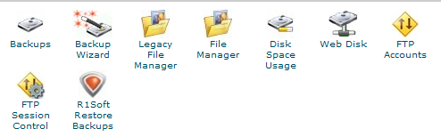
  + Click on FTP icon – This GUI bellow should appear
    - 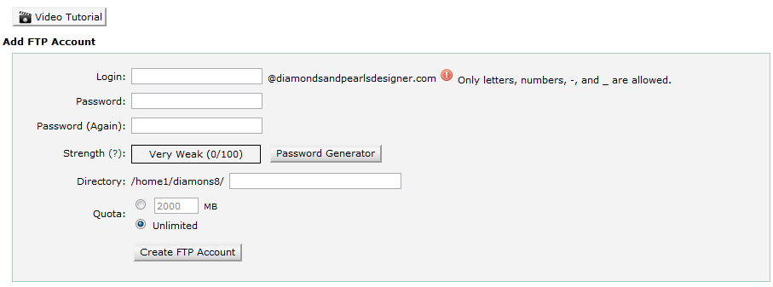
    - Fill in necessary information
    - If you need help, click on video tutorial
    - Note: Make sure you point your FTP directory to public_html
      * Asked for your webhost provider if you are having problems
    - 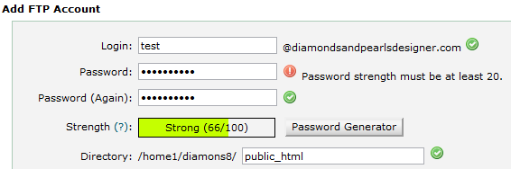
  + Save the username and password
  + Click on Configure FTP Client
    - 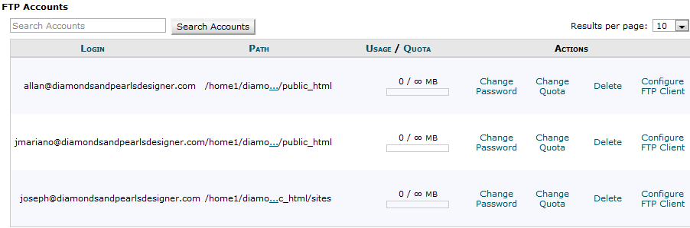
  + Save this information along with your password
  + 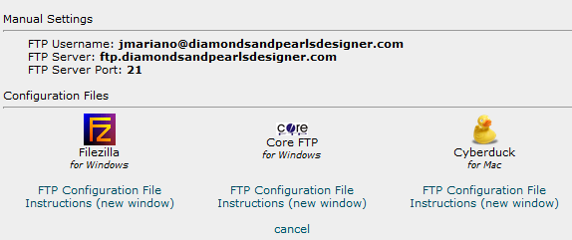
* To create a Database
  + Click on MySQL database icon
    - 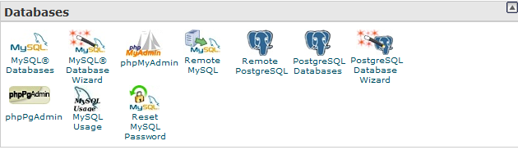
  + The icon bellow should show up
    - 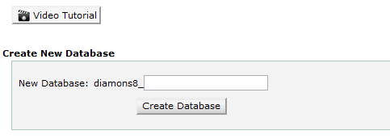
      * Fill-in the database name that you desired
      * If you need further help, click on video tutorial
      * Save the database name
  + Create a database account
    - 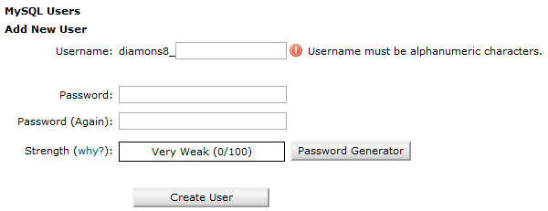
      * Fill-in the useraname name and password that for the database
      * If you need further help, click on video tutorial
      * Save the MySQL username and Password information
  + Add MySQL user account to database that you’ve just created
    - 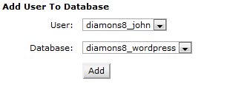
  + Now, you should be ready to install your Website CMS template

Step 4: Install Filezilla

* What is filezilla? An FTP program so you can send files to your web server.
* Go to <http://filezilla-project.org/>
  + 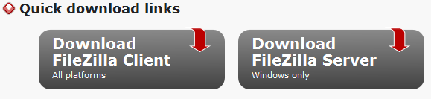
* Download Filezilla Client
  + Follow installation instruction

Step 5: Add your FTP account in your filezilla program

* Open the program
* Click file, then site manager
  + 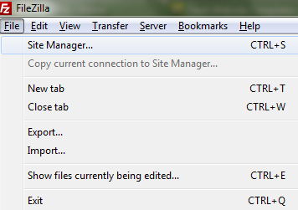
* This icon bellow should appear
  + 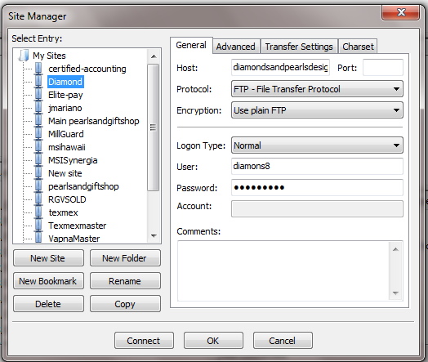
* Fill-in all necessary information from FTP accounts
  + Make sure to put a port number and your password is correct
  + If you are having a problem, contact your domain and hosting provider
* Click-connect, when finished
* This should automatically connect you to public_html directory

Step 6a: Install your html template (For CMS template go to 6b)

* Open your html template folder (Most of the time – there should be an instruction as to which file to upload)
* In your filezilla
  + the left pane should be your local computer
  + the right pane should connect to public_html (your web host)
  + 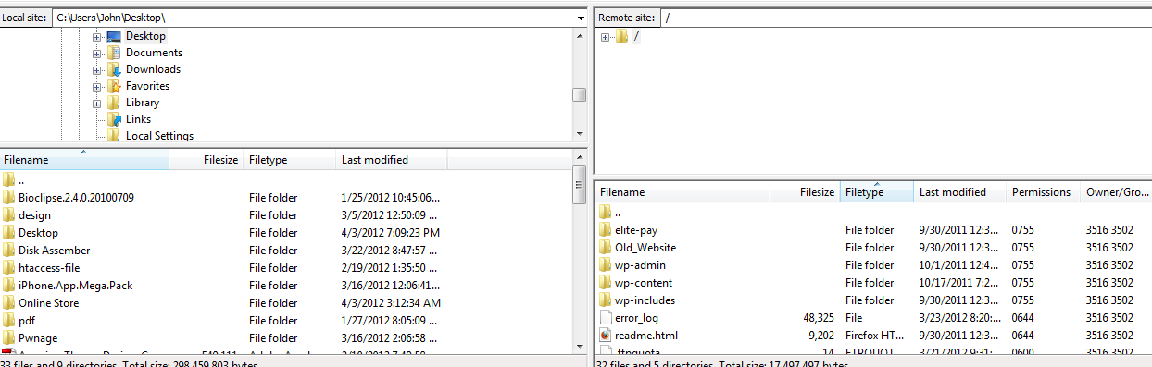
* Make sure to delete all the file inside public_html if there is any
* Just drag and drop the html file from your local computer (which is the left pane) to your web host server (the right pane)
* Your html template should now work!!!
  + Visit your site to check: www.example.com
* If you need to edit the template, please read books about html. The learning curve in learning html is not that intensive.

Step 6b: Installing CMS (We will use worpress in our example)

* Download the core CMS files from <http://wordpress.org/download/>
* Unzip or Unrar the files
* Upload the Wordpress CMS files to your web server
  + This process should be the same as 6a
* Get your database information ready (from step 3)
* 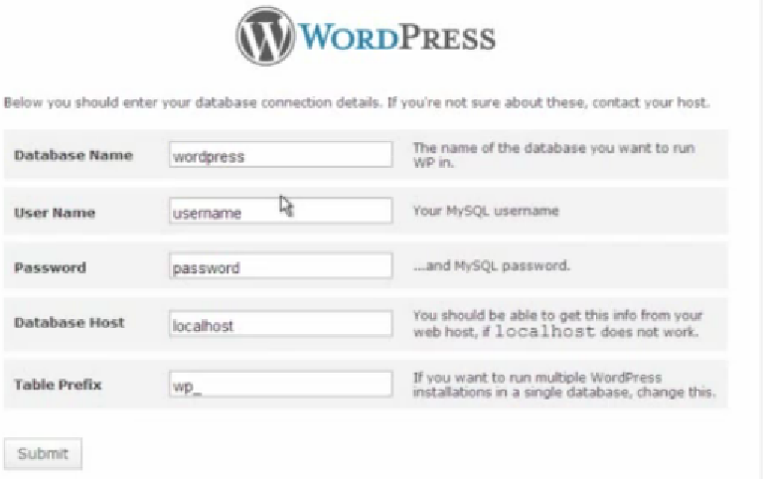
  + Fill in:
    - Database name
    - Username
    - Password
    - Database host: it should be localhost (but make sure to check your local host provider as it may vary)
    - Table Prefix: leave the default information
  + After you click submit, it should ask for your e-mail
    - Enter the any e-mail address that you have
    - Normally, this e-mail address will be your administrator’s address
  + Your wordpress CMS should now run perfectly!!!
    - Visit your site to check: www.example.com
    - A default worpress template should show
  + To login to your worpress GUI, type [www.example.com/wp-admin](http://www.example.com/wp-admin)
* Your worpress CMS is now ready for template installation?

Step 7: Installing your wordpress template

* Get your worpress template ready (see step 1)
* You should still be connected to your FTP server using filezilla
* In your remote site, navigate to wp-content/themes
  + This is where you will upload your worpress cms template
  + 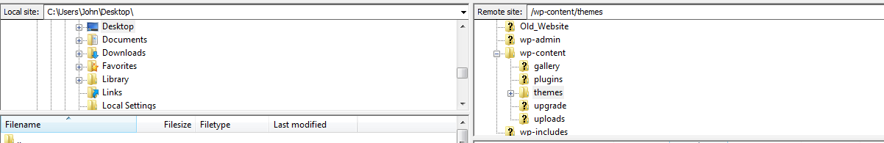
    - Upload the cms template from your local site to your remote site
* Minimize the filezilla
* Log-in to your wordpress site: [www.example.com/wp-admin](http://www.example.com/wp-admin)
* In your mid-right pane, you should see the word appearance
  + From appearance click on themes
    - Your manage themes should appear. In addition, your wordpress cms template should appear
    - 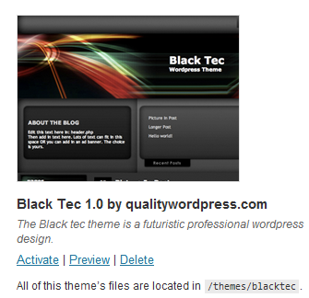
    - Now, what should you do? You guess it right. Click on activate!!!
* Logout from your site and see the changes it made in your site.
* If you need to edit your site, the template you purchased should include the instruction. If not, call the site where you download or purchase your template for help.

Author: John Paul Mariano

Work Title: Web Designer and Developer

E-mail: jppm8387@yahoo.com

Address: Edinburg, Texas USA

Website: [www.webupps.com](http://www.webupps.com)

Phone: 956-720-0663